**Middlesex University Motion Platform**

Last update M Margolis Mar 15 2021

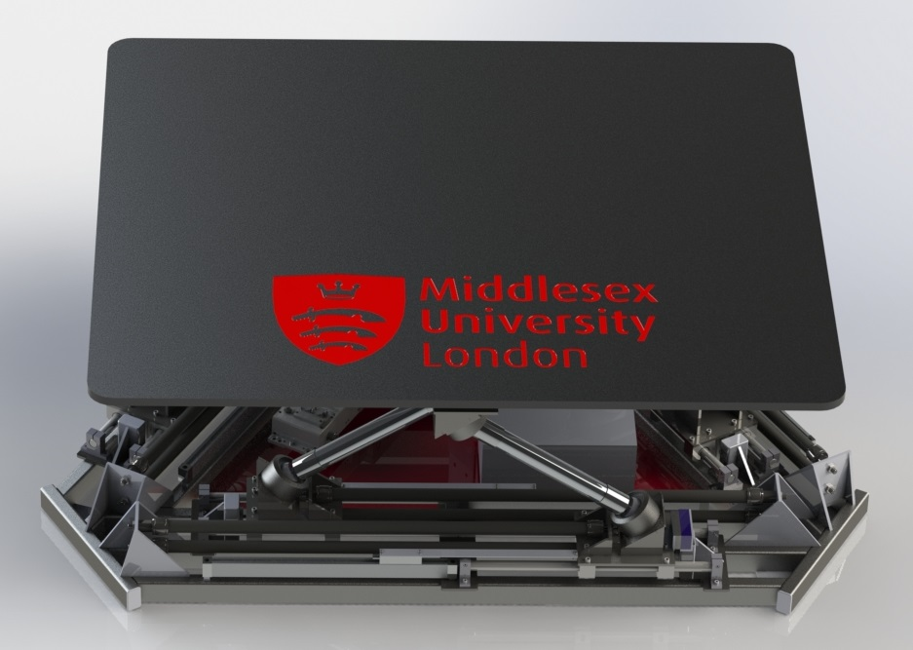

The design of the new motion system provides a large unencumbered top platform with much greater load capacity and versatility than the current chairs. The design is a modified Stewart platform where distances between attachment points is controlled by a form of slider crank mechanism actuated by pneumatic muscles. The upper platform size is 120x140cm. The maximum payload is 350Kg.

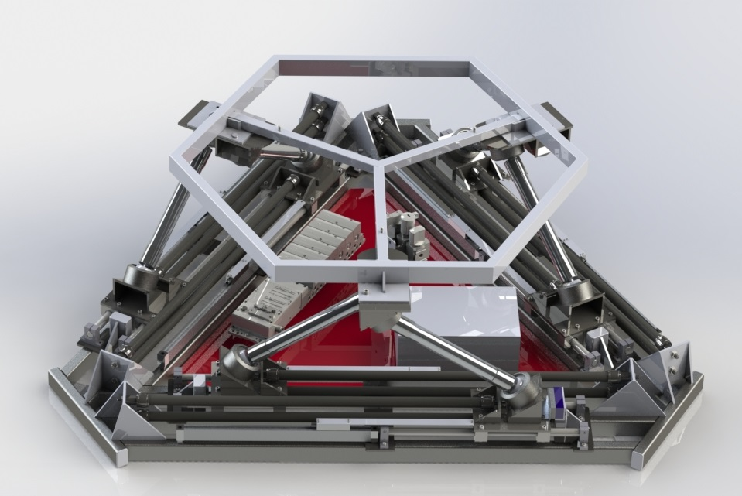Motion platform (top platform not shown)

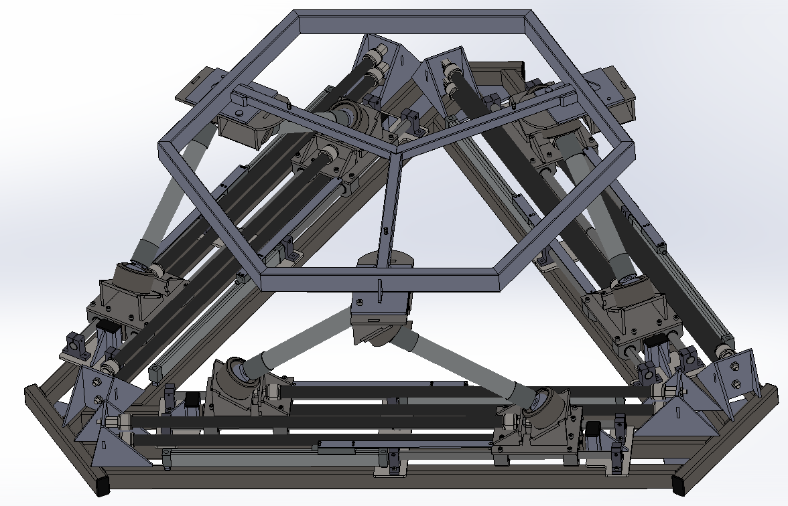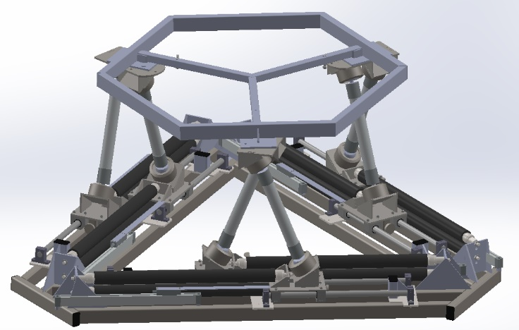

Muscles fully extended Muscles fully contracted

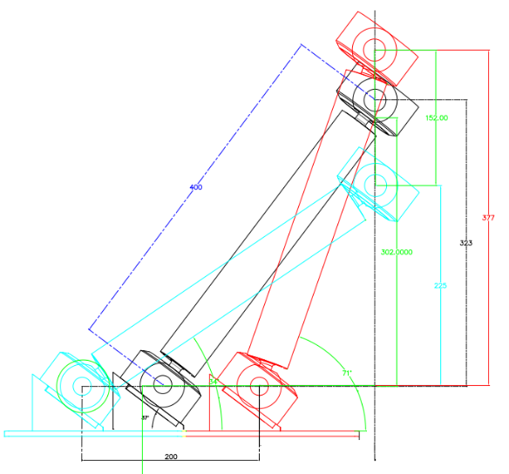

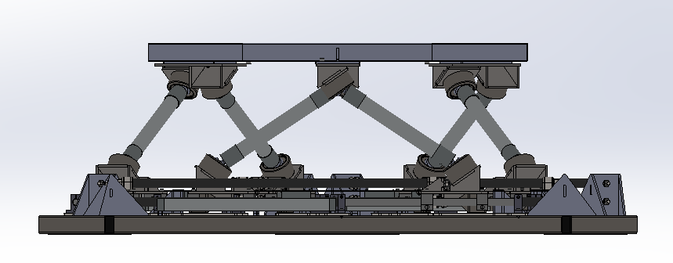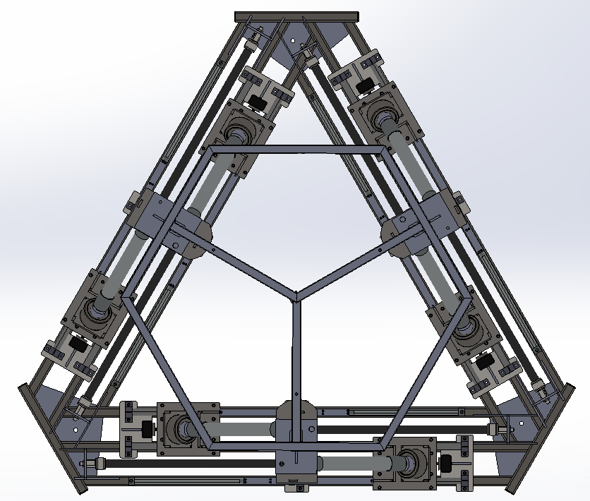

The lower attachment joints cans slide 200mm actuated by pneumatic muscles. The cranking action results in a range of 150mm of vertical movement. Six degrees of freedom of the platform are controlled by the relative position of each of the six lower attachment points.

Top view Side View

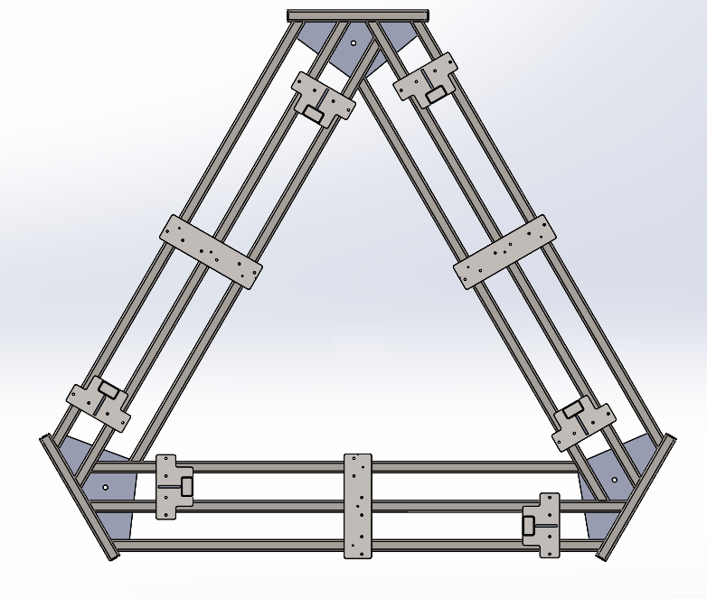

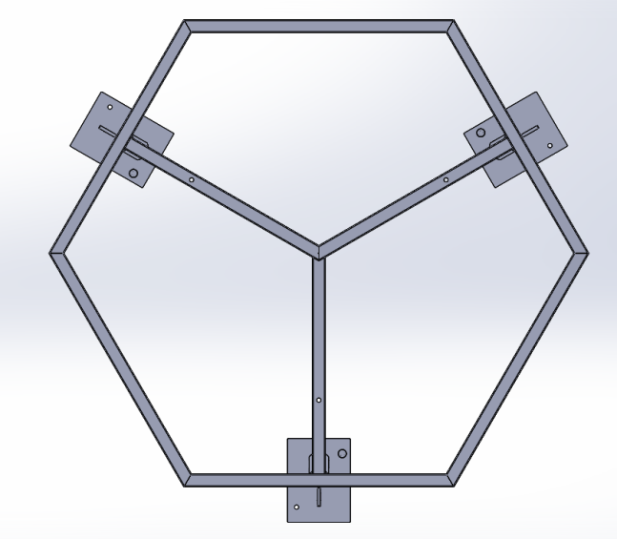

Base with mount points for actuators Top frame with mount points

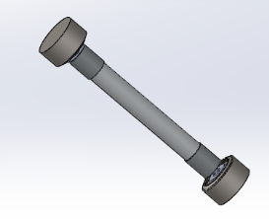

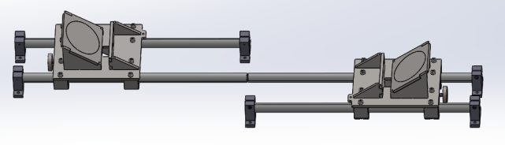

One pair actuator rails with carriages Actuator rod with ball joints

**Component details:**

Drive system: Festo pneumatic components as follows:

3473128 CPX-CEC-C1-V3 control blocks (CODESYS V3 OpenCAN)

195708 CPX-AB-8-KL-4POL manifold block (2 off)

542218 VPPM-6TA-L-1-F-0L6H-S1 proportional valve (6 off)

533370 VMPA-FB-EPL-G end plate

For ordering CPX Valve Terminal:

Part no: 530411

Configuration: 50E-T33GCQSYJNIJ-D, 32P-VGL-M6QXU-6QE

Configurator at:

https://www.festo.com/cat/en-gb_gb/products_VIMPA_FB?CurrentPartNo=530411

Regulator Assembly (service unit): Festo components as follows:

529156 MS4-LFR-1_4_D7_ERM-AS

541266 MS4-EM-1

5270709 MS4-EE-1_4-V24

For ordering MSB4 service unit, use:

Part no: 531029

Configuration: MSB4-AGC:C3:J18:D1-WP

Pneumatic Muscles: 12 off Festo DMSP 800mm 20 mm muscles (2 per actuator)

Muscle ordering details:

Part no: 541404

Configuration: DMSP-20-800N-RM-CM

Passive linear bearings: LUHR20-2LS SKF Linear Bearing Unit (24 off)

1000mm x 20mm (59 HRC + 6 HRC) linear shaft (3 off)

500mm x 20mm (59 HRC + 6 HRC) linear shaft (6 off)

Ball Joints 12 ball joints capable of supporting at least 250kg under tension

Ball swivel 38 degrees or greater

We used (vastly over specified) RPCSB05 from here:

https://www.steerforth.co.uk/weld-ball-socket-joint-p-4155.html

Linear Encoders 6 off 400mm 5 micron linear encoder (can be 350 to 450mm) for initial calibration and

automatic load adjustment. We used this:

https://uk.banggood.com/2-or-3-Axis-Grating-CNC-Milling-Digital-Readout-Display-or-50-1000mm-Electronic-Linear-Scale-Lathe-Tool-p-1340326.html?rmmds=myorder&ID=515971&cur_warehouse=USA

**Build cost estimates (excludes VAT):**

Festo components approx. £8k

Ball joints, linear bearings and misc. hardware £2k

Steel for constructing platform £ £400-£500

These costs exclude the following:

Powder coating steel components (perhaps £300)

Compressor with 6 bar capacity and at least 100-liter tank capacity (perhaps £1.5k)

Seating as required for your application

PC and display equipment as required for your application

Labor costs for fabricating the platform